Enscribe is a Database Record manager. It is a file based distributed database.

Types of Files in Enscribe:

1. **Unstructured**

It is essentially large byte array.

It is a code Edit file and can’t be used as a data file.

1. **Structured**

b.1 Relative File

b.2 Entry Sequential File

b.3 Key Sequential File

b.4 Queue File

1. ***Set Parameters for Unstructured File***

Go to FUP utility prompt after typing FUP and then enter.

Set Type U

Set EXT (500, 100)

Set MaxExtents 200

* U denotes Unstructured File
* Ext denotes memory allocation in the form of primary extent and secondary extent.
* MaxExtents denotes after consuming primary extent and first level of secondary extent, how many times you can add additional pages (as per the configuration done for MaxExtents).

Primary Extent = 500 pages (**Physical Memory**),

Secondary Extent = 100 pages and then it can be extended upto **199** times (**Physical Memory**).

Now, your Tandem environment is set and whatever file you create it will be an unstructured file

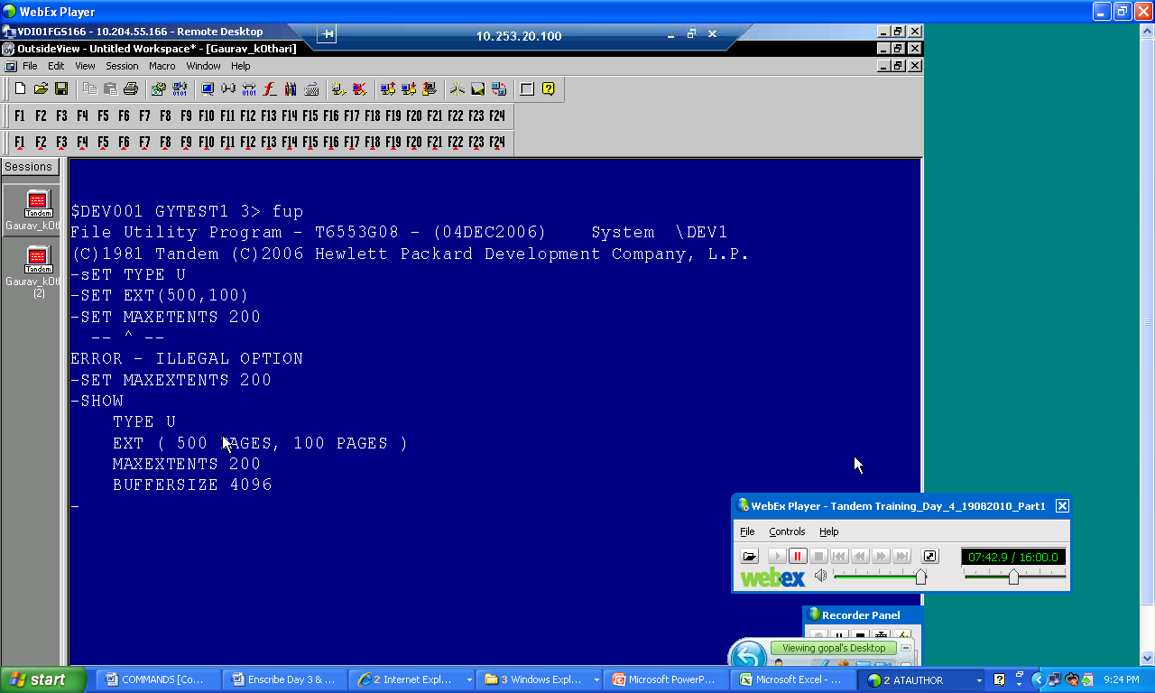

1. TACL Command> **FUP CREATE Unstruc**

(*This command will create an unstructured file as per the environmental parameters set above*)

**Buffersize = 4096 Bytes**

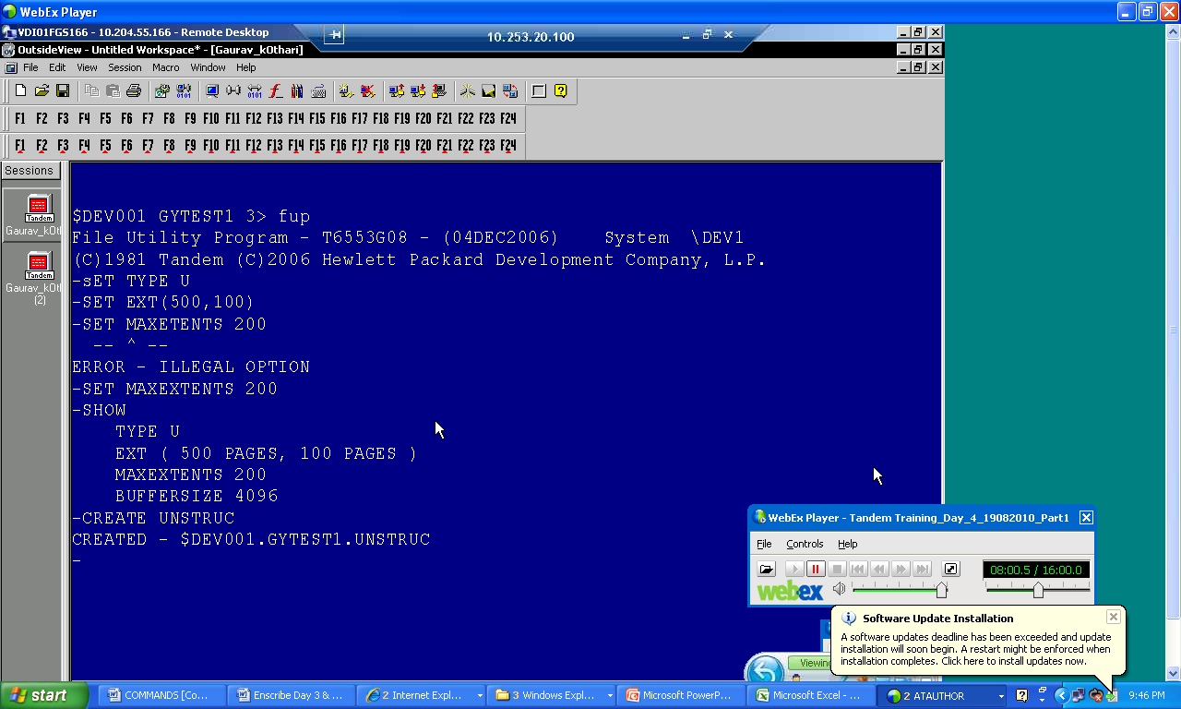

You can see an unstructured file has been created with the name “UNSTRUC”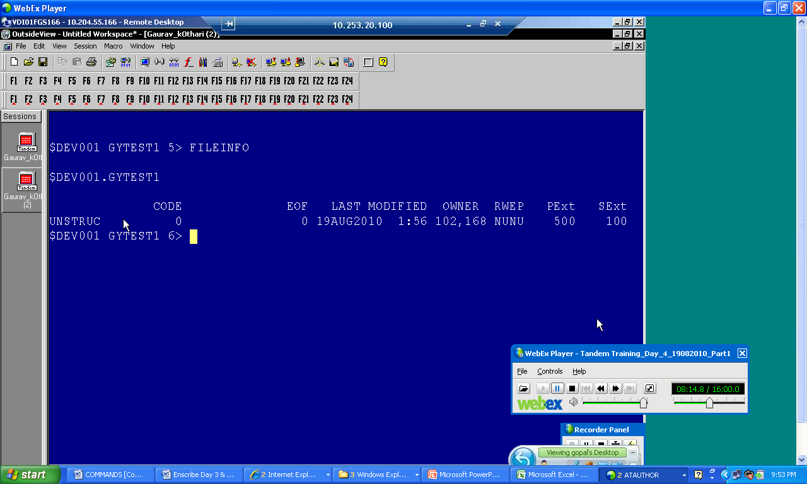

“Reset” command is used to reset the parameters set earlier. If you enter the “Show” command it will show you the default parameters.

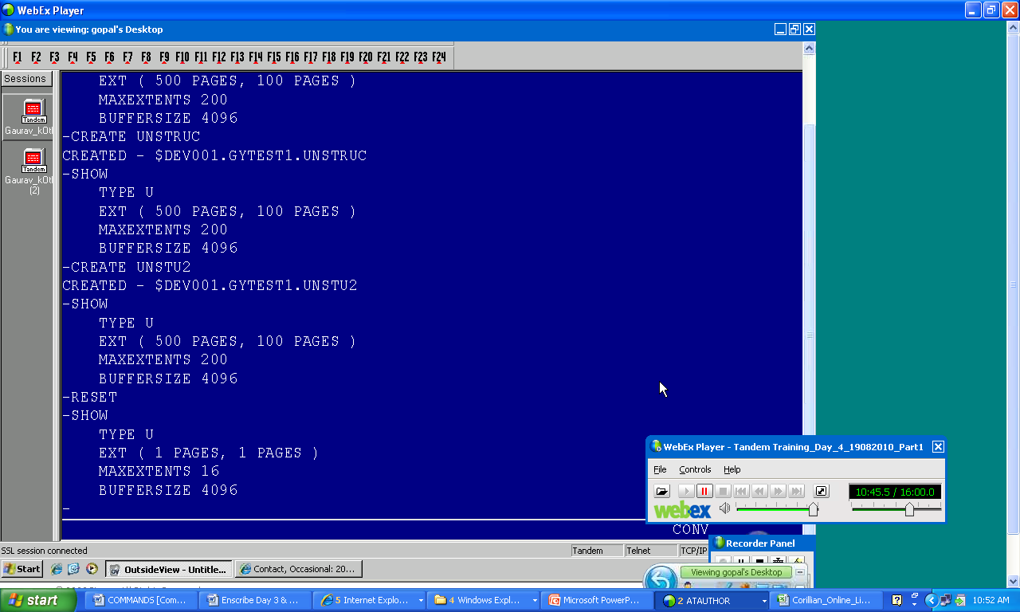

1. Structured File – Relative Files

Relative files are made up of logical records. A fixed amount of storage is used for each record, even though the data saved in the record can be of different level.

Each record in a relative file is identified by a number.

|  |  |  |  |
| --- | --- | --- | --- |
| Record # | Data | | Slack |
| 0 | Rec0 *slack* | | |
| 1 | Rec1  *slack* | | |
| 2 | Rec2  *slack* | | |
| 3 | Rec3  *slack* | | |
| *slack* | | | |
| 4 | Rec4 *slack* | | |
| 5 | Rec5  *slack* | | |
| 6 | Rec6  *slack* | | |
| 7 | Rec7 | *Slack* | |
| 8 | Rec9 | | |

BLOCK - 0

Record # 0-3 belongs to **Block 1**

4-7 belongs to **Block 2**.

Record# = Physical Key to access that record.

this symbol denotes SLACK. Slack is an empty area which cannot be utilized because of record length.

You must specify the maximum possible record length to accommodate highest possible record data within a relative files record length. Because of the variable size of the data the memory many or may not be utilized to the fullest.

Set the environmental variables to create a Relative file.

FUP Set Type R

FUP Set Ext (100, 50)

FUP Set Maxextents 100

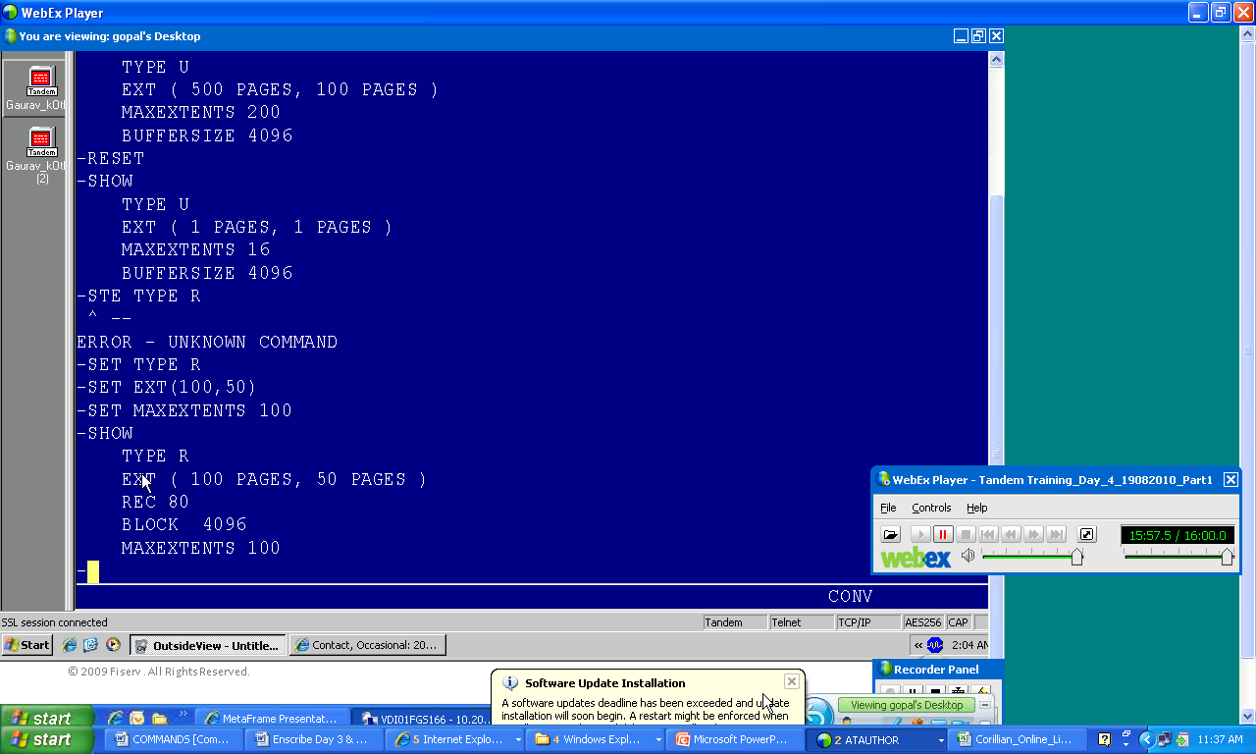

TACL Command>**FUP Create Rfile**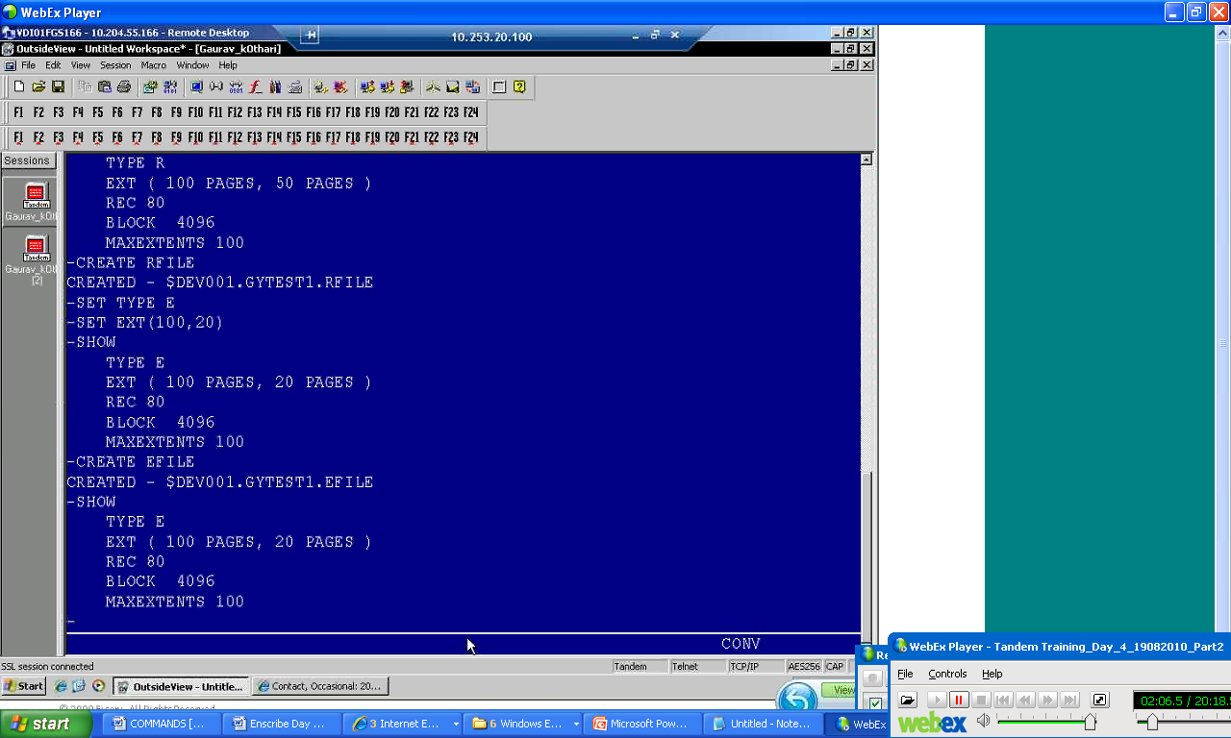

1. Structured File – Entry Sequential Files

Records in an entry-sequenced file are variable length. New records are appended to the end of the file.

|  |  |  |
| --- | --- | --- |
| Data | | |
| Rec0 Rec1 | | |
| Rec2 Rec3 | | |
| Rec4 Rec5 | | |
| Rec6 Rec7 | | |
| Rec8 | | *slack* |
| Rec9 | | |
| Rec10 | | |
| Rec11 Rec12 | | |
| Rec13 | *slack* | |

BLOCK - 0

BLOCK - 1

this symbol denotes SLACK. Slack is an empty area which cannot be utilized because of record length. End of the block will have a slack if the record length of the next record cannot be fitted within that block.

Set the environmental variables to create a Entry Sequencial file.

FUP Set Type E

FUP Set Ext (100, 20)

FUP Set Maxextents 100

Now, create the Entry Sequential File.

>**FUP Create Efile**

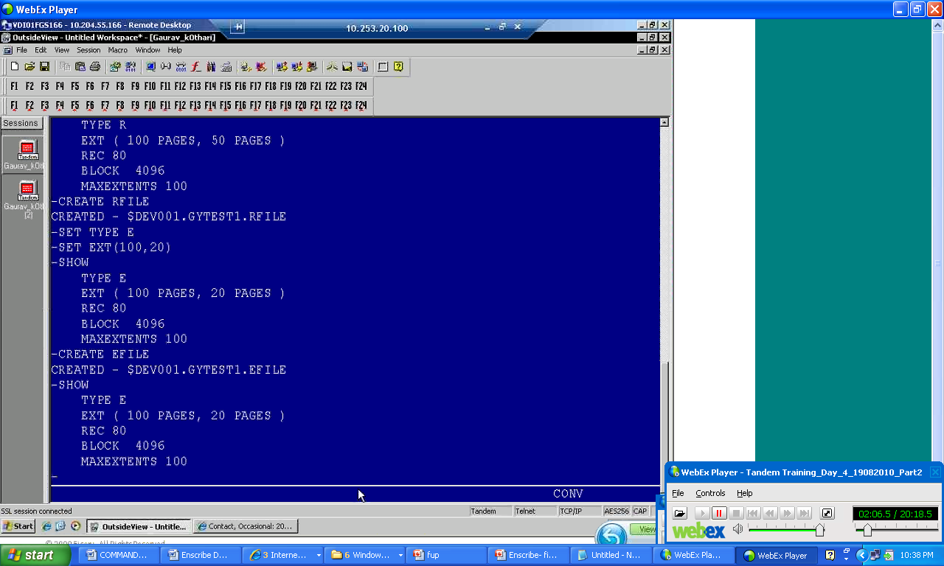

1. **Structured File – Queue** **Files** (*Key seq. file and queue seq. file format is same*)

Search can be done faster with Key Sequential file, it works on the principal of binary tree.

Index Level=0

Index Level=1

Index Level = 2

TACL Command> FUP Set Type K

> FUP SET QUEUEFILE

**> FUP SET KEYLEN 10**

> FUP SET EXT (20, 10)

> FUP Create Qfile

*Note:*

***FUP Set Queuefile*** *command will not be used in case of Key seq. file. It will be used only used in case of Q seq. file*

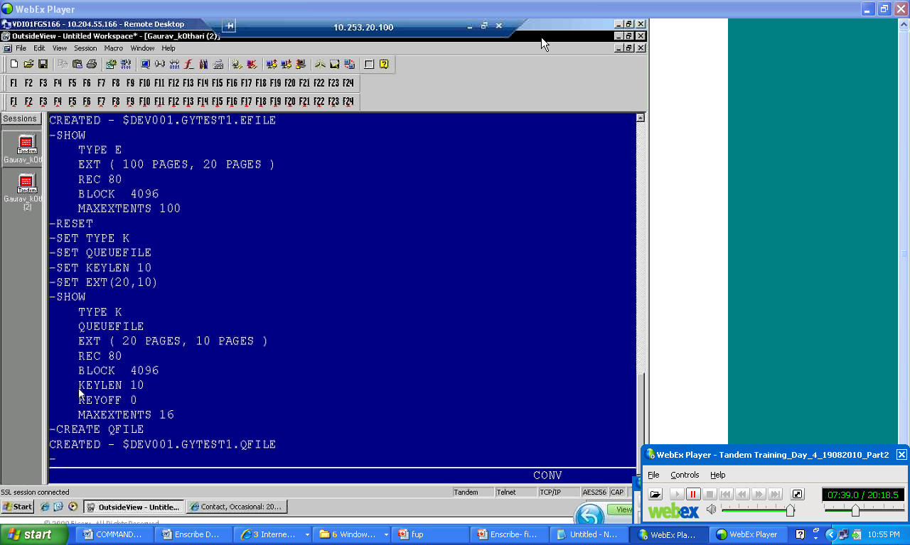

You can refer the files created in the steps above.

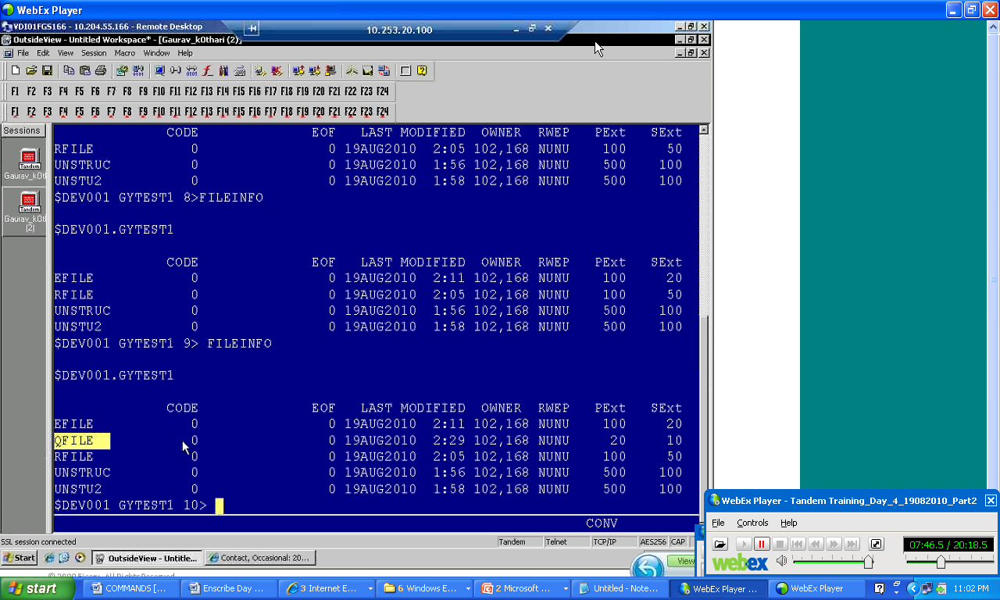

1. **Structured File – Partitioned** **Files**

A file which is divided into number of partitions. These partitions can reside in different volumes of disk. Up to 16 partitions are allowed. A file can have up to 978 extents in all the partition combined together.

Advantages:

- Size of file is not limited by size of disk.

- Increased concurrency of access.

- It can accommodate more locks.

How to create this file?

1. **File Formats**

**Format 1 (why we need a partition or unpartition files size)**

Maximum partition size = 2 GB – 1 KB

Max Partitioned File size = 4 GB - 4KB

Max Unpartitioned File size = 2 GB – 1 KB

Maximum block size = 4 KB

Maximum record size =[block – 24] (Entry-sequenced and Relative file)

Maximum record size =[block – 34] (Key Sequenced)

**Format 2**

Maximum partition size = 1024 GB

Max Partitioned File size = 1024 GB

Max Unpartitioned File size = 1024 GB

Maximum block size = 4 KB

Maximum record size =[block – 48] (Entry-sequenced and Relative file)

Maximum record size =[block – 56] (Key Sequenced)

1. TACL Command> **FUP Set Format 2**

>**Create UN2**

(*this command will create a format 2 file*)

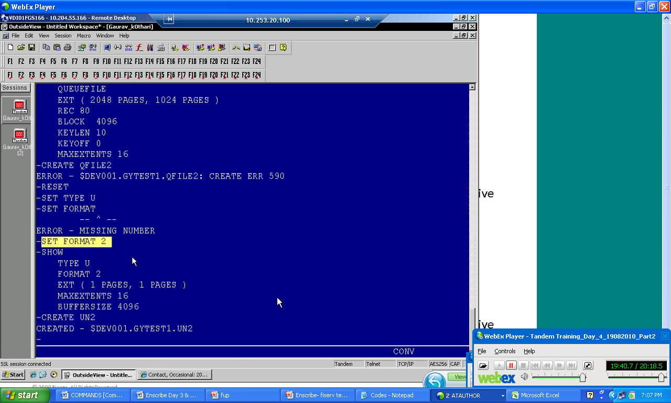

**+** denotes that it is a format 2 file.

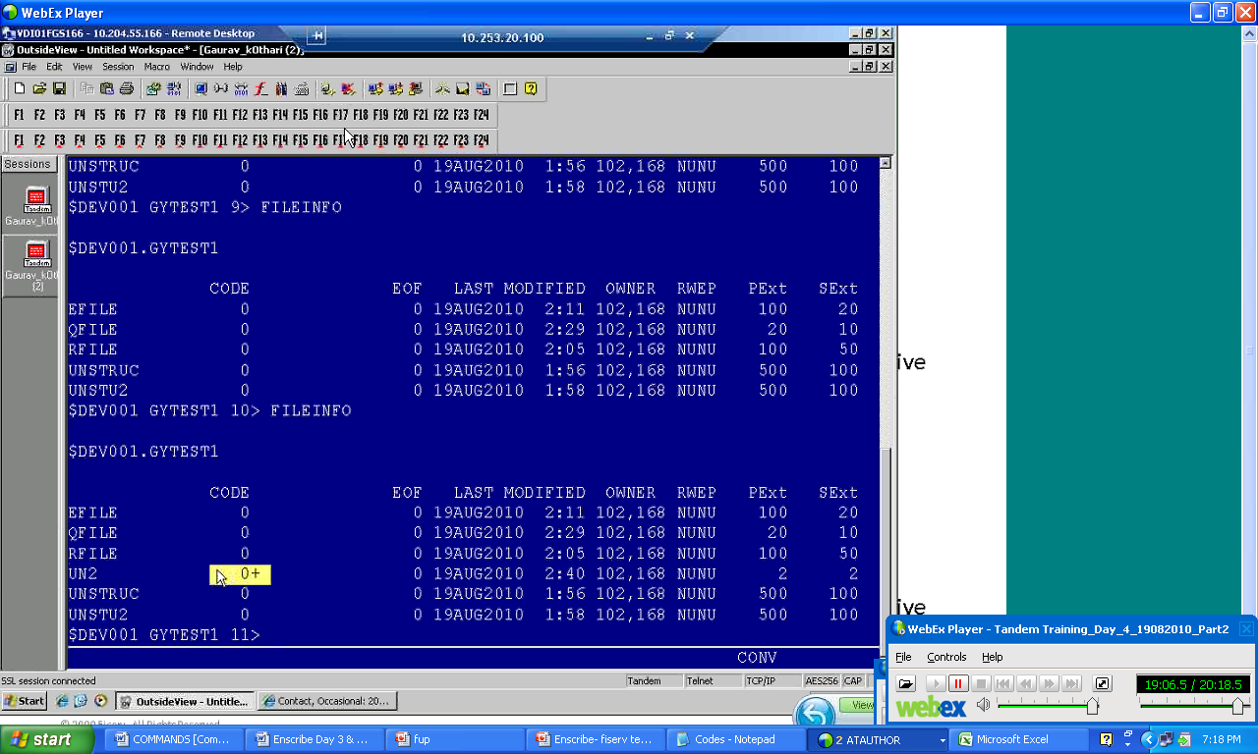

1. $DEV001 GYDATA1 8> fup

(*this command will enable you to enter FUP prompt/FUP Utility prompt*)

File Utility Program - T6553G08 - (04DEC2006) System \DEV1

(C)1981 Tandem (C)2006 Hewlett Packard Development Company, L.P.

- show

(“*-“ is the FUP prompt. Show command will show the environmental attributes*)

TYPE U

EXT ( 1 PAGES, 1 PAGES )

MAXEXTENTS 16

BUFFERSIZE 4096

-set like $$ okc.cmdata.cmdcp

(*set command will set the environmental attributes as per the environmental attributes set for the file cmdcp*)

-show

TYPE K

FORMAT 1

EXT ( 4 PAGES, 32 PAGES )

REC 168

BLOCK 4096

KEYLEN 20

KEYOFF 0

LOCKLENGTH 20

AUDIT

MAXEXTENTS 100

BUFFERED

-create cpre

(*create command will create a file with the name CPRE*)

CREATED - $DEV001.GYDATA1.CPRE

-exit

(*exit command will help you in exiting the FUP session*)

$DEV001 GYDATA1 9> fileInfo

(*fileinfo command will show you the file details.*)

$DEV001.GYDATA1

CODE EOF LAST MODIFIED OWNER RWEP PExt SExt

ALTCL0 0A 12288 23AUG2010 4:23 102,168 NUNU 4 32

CLIENT 0A 12288 23AUG2010 4:23 102,168 NUNU 4 32

CPRE 0A 0 25AUG2010 0:21 102,168 NUNU 4 32

EDITFILE 101 2086 22AUG2010 23:16 102,168 NUNU 6 6

KEYFILE 0 0 22AUG2010 23:31 102,168 NUNU 2 2

KEYFILE1 0 0 25AUG2010 0:11 102,168 NUNU 100 50

KEYFILE2 0 0 23AUG2010 0:55 102,168 NUNU 2 2

QFILE 0 0 23AUG2010 0:32 102,168 NUNU 2 2

RELFILE 0 0 22AUG2010 23:18 102,168 NUNU 100 50

RELFILE2 0 0 22AUG2010 23:22 102,168 NUNU 100 50

UNST 0 0 22AUG2010 23:14 102,168 NUNU 100 50

UNST2 101 2078 22AUG2010 23:17 102,168 NUNU 100 50

$DEV001 GYDATA1 12> KLIST $OKC.CMDATA.CMDCP,FIRST 540,C

(*Klist command will display all the records of the file CMDCP after skipping first 540 records. Klist =Command name, $OKC = Volume, CMDATA=Sub-Volume name, CMDCP=FileName* )

$DEV001 GYDATA1 12..

....+....1....+....2....+....3....+....4....+....5....+....6....+....7....+....8

....+....9....+....0....+....1....+....2....+....3....+....4....+....5....+....6

....+...

99999999486130 16A06AD68010N12SNON082 YXXXX XXXX 444UN N2Y NYYY

YYYD N 091027042325FGSTEST05

99999999486140 16A06AD00003N12MM10000 NXXXX XXXX XXXX XXXX101 N N1N NNNN

NNND N 091027025244FGSTEST05

RECORDS SELECTED= 2

**$DEV001 GYDATA1 13> KLIST $OKC.CMDCPATA.CMDCP,PUT CPRE, FIRST 540,C**

**(*this command is coping the data from CMDCP file into CPRE file after skipping first 540 records. Why we are using two PUT keywords and let me knows other switches to copy or append the contents in a file*)**

....+....1....+....2....+....3....+....4....+....5....+....6....+....7....+....8 (record 541- Record length = 80)

....+....9....+....0....+....1....+....2....+....3....+....4....+....5....+....6 (record 542 - Record length = 80)

....+...

99999999486130 16A06AD68010N12SNON082 YXXXX XXXX 444UN N2Y NYYY

YYYD N 091027042325FGSTEST05

99999999486140 16A06AD00003N12MM10000 NXXXX XXXX XXXX XXXX101 N N1N NNNN

NNND N 091027025244FGSTEST05

RECORDS SELECTED= 2

$DEV001 GYDATA1 14> FileInfo

*(Once you copied the date from CMDCP file into CPRE file this command will show the file size)*

$DEV001.GYDATA1

CODE EOF LAST MODIFIED OWNER RWEP PExt SExt

ALTCL0 0A 12288 23AUG2010 4:23 102,168 NUNU 4 32

CLIENT 0A 12288 23AUG2010 4:23 102,168 NUNU 4 32

CPRE 0A 12288 25AUG2010 0:24 102,168 NUNU 4 32

EDITFILE 101 2086 22AUG2010 23:16 102,168 NUNU 6 6

KEYFILE 0 0 22AUG2010 23:31 102,168 NUNU 2 2

KEYFILE1 0 0 25AUG2010 0:11 102,168 NUNU 100 50

KEYFILE2 0 0 23AUG2010 0:55 102,168 NUNU 2 2

QFILE 0 0 23AUG2010 0:32 102,168 NUNU 2 2

RELFILE 0 0 22AUG2010 23:18 102,168 NUNU 100 50

RELFILE2 0 0 22AUG2010 23:22 102,168 NUNU 100 50

UNST 0 0 22AUG2010 23:14 102,168 NUNU 100 50

UNST2 101 2078 22AUG2010 23:17 102,168 NUNU 100 50

$DEV001 GYDATA1 15> KLIST CPRE

99999999486130 16A06AD68010N12SNON082 YXXXX XXXX 444UN N2Y NYYY

YYYD N 091027042325FGSTEST05

99999999486140 16A06AD00003N12MM10000 NXXXX XXXX XXXX XXXX101 N N1N NNNN

NNND N 091027025244FGSTEST05

RECORDS SELECTED= 2